**Excel Assignment - 21**

**1. Write a VBA code to enter your name in A1 Cell using Input Box and**

**once you enter the name display a message box that says the name**

**has been entered.**

Sub vba_inputbox()

Cells(1, 1).Select

ActiveCell = InputBox("What's your name?", "Enter Name")

MsgBox ("Name has been entered.")

End Sub

**2. What are Userforms? Why are they used? How to fill a list box using**

**for loop.**

A UserForm is basically a pop-up window that you can use to create a custom interface for Excel.

This pop-up window allows you to have a more user-friendly interface and to automate Excel in many ways using VBA and macros. In the pop-up window, you can have many different kinds of buttons, user input areas, and layouts.

A UserForm creates a visual interface but, behind it all, is the code that runs it, the VBA and macros. When you click a button within a UserForm, you are causing a piece of code to run. This code can be placed wtihin the UserFrom itself or within regular modules with other macros.

Below are the few reason is to why we use UserForms:

* UserForms make the input and display of data clean and easy-to-understand.
* UserForms seamlessly interact with worksheets and can be used to put data into and get data from them.
* You can customize just about every part of a UserForm to get it to look like you want and say what you want.

Private Sub UserForm_Initialize()

With UserForm1.ListBox1

Dim i As Integer

For i = 1 To 5

.AddItem i

Next i

End With

**3. What is an array? Write a VBA code to enter students and their marks**

**from the below table.**

A VBA array in excel is a storage unit or a variable which can store multiple data values. These values must necessarily be of the same data type. This implies that the related values are grouped together to be stored in an array variable.

As table is not given, I’m going to assume a table and write a VBA code for that.

Consider an example of storing marks of 2 students obtained in 3 subjects. So we will create a 2-dimensional array that takes 2 rows and 3 columns.

We will start the array from row 1 to row 2 and column 1 to column 3.

Sub Twodim()

Dim totalMarks(1 To 2, 1 To 3) As Integer

totalMarks(1, 1) = 23

totalMarks(2, 1) = 34

totalMarks(1, 2) = 33

totalMarks(2, 2) = 55

totalMarks(1, 3) = 45

totalMarks(2, 3) = 44

Msgbox “Total Marks in Row 2 and column 2 is “ &totalMarks(2,2)

Msgbox “Total Marks in Row 1 and column 3 is “ &totalMarks(1,3)

End Sub

**4. Use the following data to create a pie chart using VBA code. Use Font**

**- ‘Times new Roman’, Size -14, Bold, Title - Piechart’ and you are free**

**to use colours as per your taste.**

As data is not provided, I’m assuming the below data table and creating Pie-Chart over it using VBA.

|  |  |  |
| --- | --- | --- |
|  | A | B |
| 1 | **Region** | **Sales** |
| 2 | Region A | 500 |
| 3 | Region B | 700 |
| 4 | Region C | 800 |
| 5 | Region D | 770 |

**VBA Code:**

Sub SpecifyAChartType()

Dim chrt As ChartObject

Set chrt = Sheets("Sheet1").ChartObjects.Add(Left:=180, Width:=270, Top:=7, Height:=210)

chrt.Chart.SetSourceData Source:=Sheets("Sheet1").Range("A1:B5")

chrt.Chart.ChartType = xlPie

End Sub

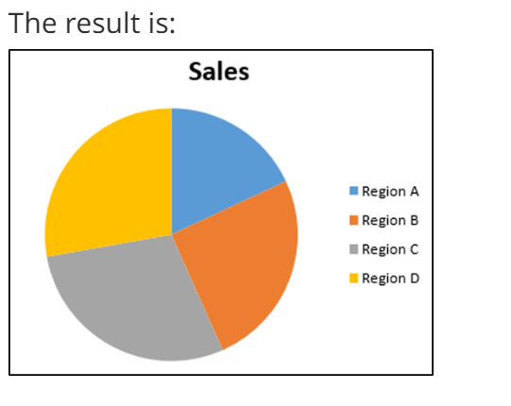

**5. Check the dataset in the link given below and create a pivot table using**

**VBA showing the sales for the year from stationary category.**

**https://docs.google.com/spreadsheets/d/1IRSEnmgz8Ro276-**

**GslknRNk0zlrB5CZH1YrnT71kqFM/edit?usp=sharing**

Sub PivotTable()

Dim PTable As PivotTable

Dim PCache As PivotCache

Dim PRange As Range

Dim PSheet As Worksheet

Dim DSheet As Worksheet

Dim LR As Long

Dim LC As Long

On Error Resume Next

Application.DisplayAlerts = False

Application.ScreenUpdating = False

Worksheets("Pivot Sheet").Delete 'This will delete the exisiting pivot table worksheet

Worksheets.Add After:=ActiveSheet ' This will add new worksheet

ActiveSheet.Name = "Pivot Sheet" ' This will rename the worksheet as "Pivot Sheet"

On Error GoTo 0

Set PSheet = Worksheets("Pivot Sheet")

Set DSheet = Worksheets("Sheet1")

'Find Last used row and column in data sheet

LR = DSheet.Cells(Rows.Count, 1).End(xlUp).Row

LC = DSheet.Cells(1, Columns.Count).End(xlToLeft).Column

'Set the pivot table data range

Set PRange = DSheet.Cells(1, 1).Resize(LR, LC)

'Set pivot cahe

Set PCache = ActiveWorkbook.PivotCaches.Create(xlDatabase, SourceData:=PRange)

'Create blank pivot table

Set PTable = PCache.CreatePivotTable(TableDestination:=PSheet.Cells(1, 1), TableName:="Sales_Report")

'Insert Product to Row Filed

With PSheet.PivotTables("Sales_Report").PivotFields("Product")

.Orientation = xlRowField

.Position = 1

End With

'Insert Segment to Column Filed & position 1

With PSheet.PivotTables("Sales_Report").PivotFields("Category")

.Orientation = xlColumnField

.Position = 1

End With

'Insert Sales column to the data field

With PSheet.PivotTables("Sales_Report").PivotFields("Amount")

.Orientation = xlDataField

.Position = 1

End With

'Format Pivot Table

PSheet.PivotTables("Sales_Report").ShowTableStyleRowStripes = True

PSheet.PivotTables("Sales_Report").TableStyle2 = "PivotStyleMedium14"

'Show in Tabular form

PSheet.PivotTables("Sales_Report").RowAxisLayout xlTabularRow

Application.DisplayAlerts = True

Application.ScreenUpdating = True

End Sub

**Result:**

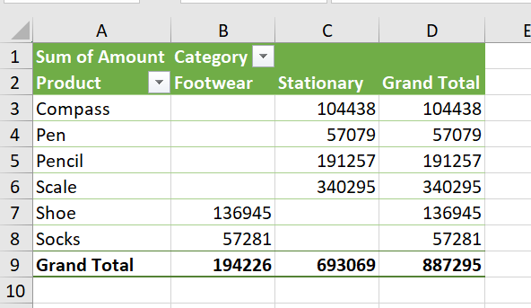

**6. Write step by step procedure to protect your workbook using a**

**password.**

**Protect an Excel file**

1. Select File > Info.
2. Select the Protect Workbook box and choose Encrypt with Password.
3. Enter a password in the Password box, and then select OK.
4. Confirm the password in the Reenter Password box, and then select OK.